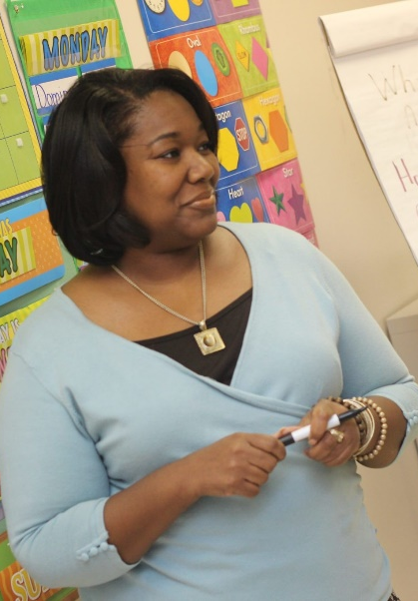
Langmoor Primary School


Safeguarding Induction
Child Protection and Safer Working in Education

Child Protection
This leaflet summarizes your child protection responsibilities but you must also read your organisation’s child protection/safeguarding policy and Part 1 or Annex A of “Keeping children safe in education” (and Annex B for those working directly with children). It is important that you know the name of your Designated Safeguarding Lead (DSL) and any deputies so you can promptly report in writing any concern about a child’s wellbeing or safety.
Signs of abuse may be clear immediately
- A non-accidental injury such as finger marks, burns or bruises
- A child tells you they have been harmed
- A child or adult tells you they are worried about a child
- You are told that a child is in a home where there is domestic abuse
- A child behaves in a way that is inappropriate for their age eg sexual behaviour or use of language
Some signs become clearer over time
- A child is often dirty, hungry or wears unsuitable clothing
- Their standard of school work decreases or they become isolated from friends or family
- Use of drugs and/or alcohol
- Self-harm becomes apparent
- Their online behaviour is a concern – it is the responsibility of all adults in school to understand their role in monitoring children’s online activity and to report concerns to the DSL
- A child is missing or absent from school for prolonged periods or repeatedly
- Significant changes in behaviour or mood

What to do:
- Promptly report your concern in writing to the DSL, signed and dated
- Keep it confidential on a “need to know basis”
- Do not investigate or ask the child any leading questions or talk to parents/carers
If a child discloses abuse:
- Take it seriously and reassure the child
- Do not promise confidentiality
- Write down the child’s words as best as you can remember, include time, day, date and signature, then pass this to the DSL
What happens after you report a concern?
- The DSL will decide whether it needs to be passed on to Children’s Services (social care)
- You must take action if you are still worried about a child or feel unable to report to the DSL for any reason – report to the headteacher or directly to social care yourself if necessary – 0116 305 0005 (Leicestershire)
Statutory Duties:
- Teachers have a duty in law to report knowledge or a disclosure of female genital mutilation to the Police
- You should also tell the DSL
- Schools are subject to the ‘Prevent Duty’ and staff must report concerns to the DSL about children who may have been radicalised into an extreme or violent ideology which may possibly lead them into committing crimes
Name of Deputy DSLs (if any)
Ryan Upfield
Kim Mayer-Gibb
Name of DSL
Helen Bonser

Safer working practice
The nationally recognised document, “Guidance for Safer Working Practice for those who work with Children and Young People in Education settings” should be read and understood in full. This is your code of conduct which sets out the standards of safe behaviour that need to be adopted when working with children. This section below summarises some key points from that guidance.
Breaches of the guidance could result in criminal or disciplinary action

Definitions

Staff means all adults working with children in whatever capacity whether paid or unpaid.
Children means those under 18 years of age but safeguarding guidance also applies to students who are 18 or over and on roll in the education setting.

Principles which underpin the guidance

Staff should:
- Know that the welfare of children is always paramount
- Know what their safeguarding responsibilities are
- Take responsibility for their own actions and behaviour, avoiding conduct which could lead a reasonable person to question their motives
- Use the same professional standards regardless of the age, ability, race, ethnic or national origin, gender, religion or belief, sexual orientation, marital status etc
Safer working practices
- Staff must not disclose information about children and families including all confidential matters within school
- Staff must not misuse their position and need to understand the power and influence they exercise over children they work with
- Staff behaviour must be professional at all times, including their dress, use of language and online communication - which always has the potential to be seen publicly
- Adults have the right to use reasonable physical force in school to keep children safe but this must never be used inappropriately. They should follow relevance guidance and incidents must be recorded and reported immediately
- Any physical contact should be only what’s needed, age appropriate and able to be justified
- Intimate care and first aid should only be given in accordance with agreed procedures
- Adults should not offer lifts to children unless it is an agreed requirement eg transport to a sports match. Impromptu or emergency transport of children should be reported and must be able to be justified
- Adults should not receive gifts other than small tokens of thanks eg at the end of a year
- Adults should not give gifts unless it is an understood reward system and available equally to all children
- Staff should not have personal email or phone conversations with children. This includes all social media, video chat and online communication.

- Out of school contact with children must be planned and agreed with senior staff and parents. Appropriate social contact will be easily recognised and openly acknowledged (eg where a staff member and a parent/carer are in the same, previously established, social group)
- References to sex and other sensitive material should be agreed and authorised by senior staff, as part of the curriculum, so that there cannot be any misinterpretation
- Online learning and use of the internet should be according to school policy. Inappropriate content must not be accessed. Misuse by children and any concerns about the effectiveness of filtering and monitoring must be reported to the DSL
- There should be no unauthorised photography of children and personal devices should not be used. Photographs of children are the property of the school and must not be transferred to personal devices
- Staff should guard against young people developing an infatuation with them and report any such concern to senior staff
- Staff should be mindful about situations where a child or their parent/s comes to depend on them for support and discuss with a senior staff member
- Staff are in a position of trust and must never allow a sexual relationship to develop with a pupil. Communication with pupils must never be sexually suggestive
Concerns about the conduct of a member of staff
- Any concern that a member of staff or volunteer may be a risk to children must be reported to the headteacher immediately. Put the concern in writing (signed and dated) and report what has been said or noticed
- If you see that a colleague has breached the guidance for Safer Working Practice, you must also report this to the headteacher. All schools must have a low-level concerns policy about this.
- If the concern is about the behaviour of the headteacher you must report this to the chair of governors or proprietor of an independent school, or in their absence, you should contact the LADO at the local authority as soon as possible on 0116 305 4141 (Leicestershire)
- Keep the matter confidential
- Do not alert the person you are concerned about as this could compromise an investigation
- Follow procedures but you have a duty to ensure matters are taken forward and can contact the LADO yourself if necessary

Contacts
First Response for referrals and advice about children 0116 305 0005
Out of hours emergencies about children 0116 305 0005
Leicester City Social Care (for children living at City addresses) 0116 454 1004
Version 09/23 (2)
Rutland Social Care (for children living in Rutland) 01572 758 407
Local Authority Designated Officer (LADO) Leicestershire 0116 305 4141

